



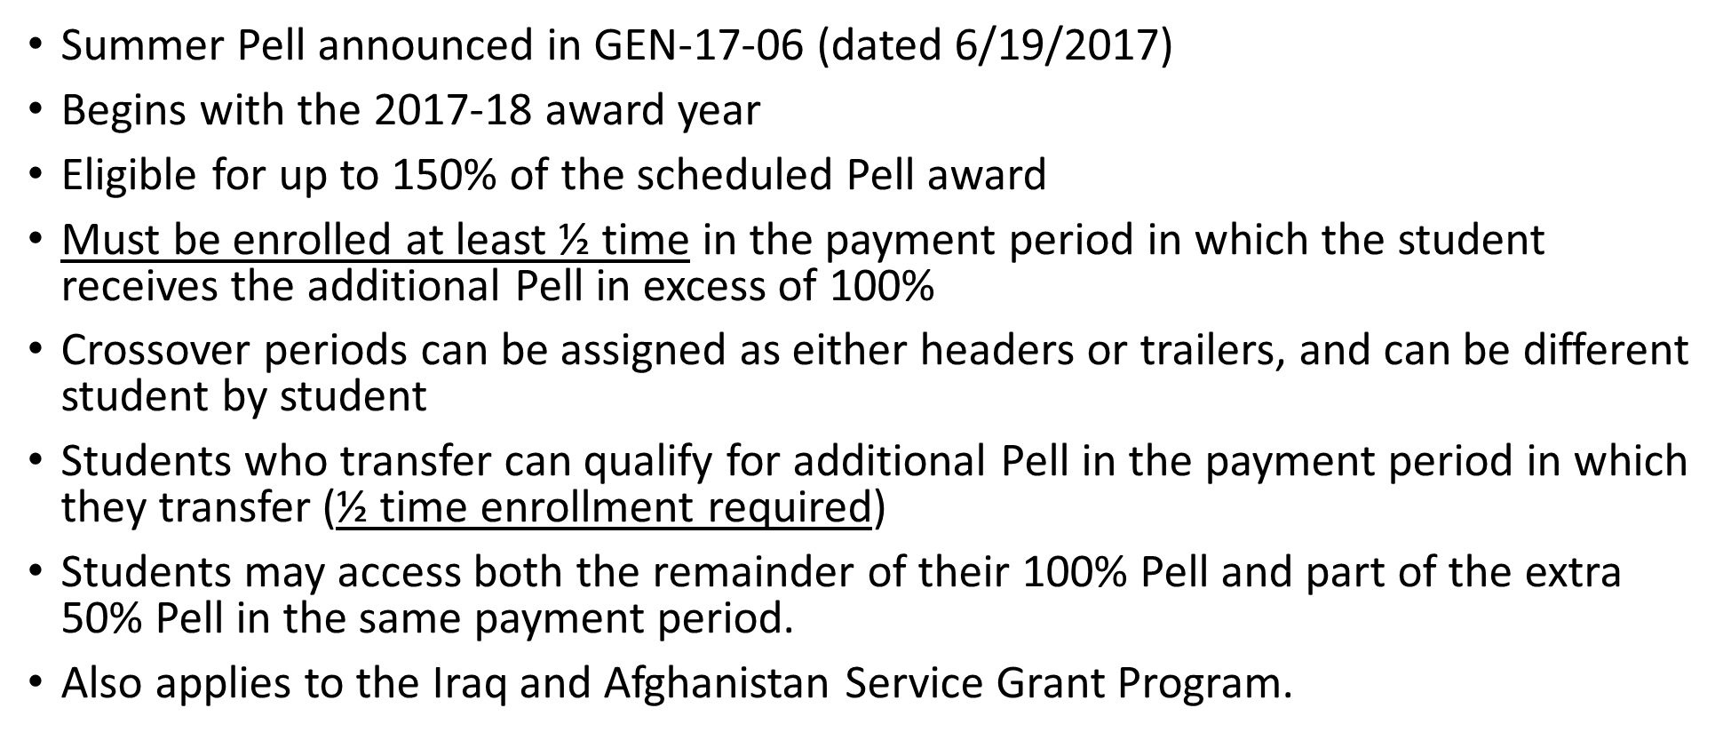



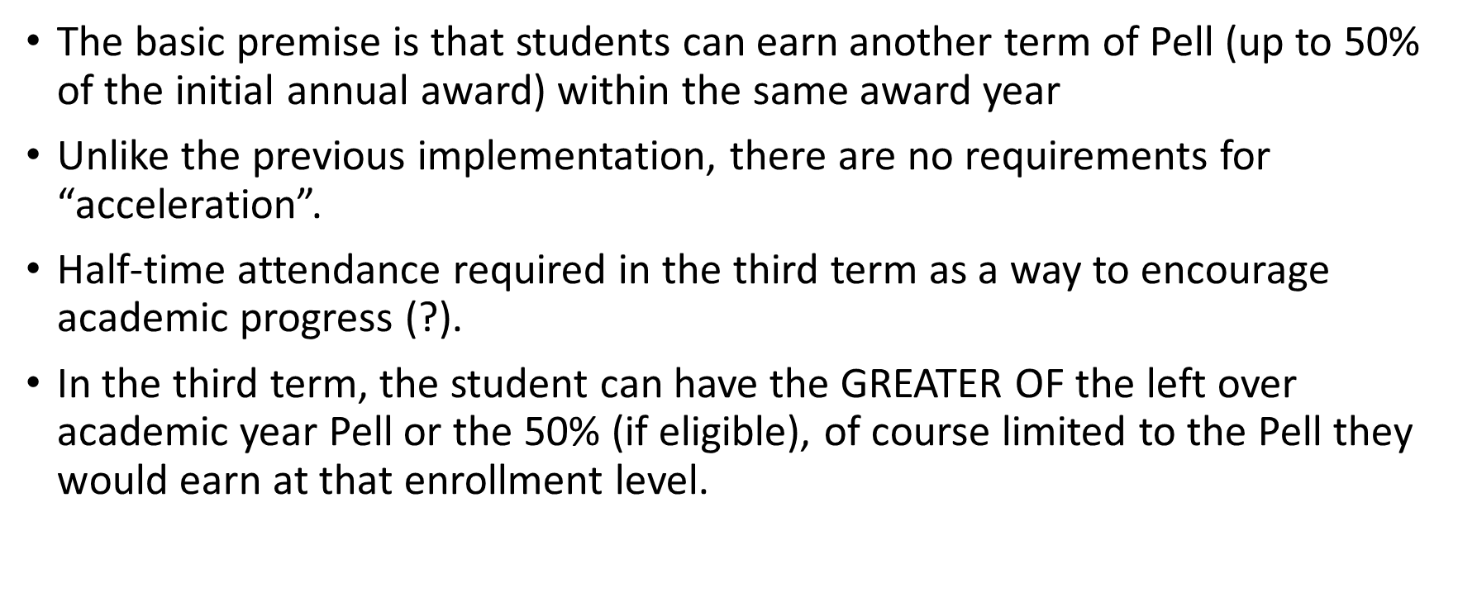

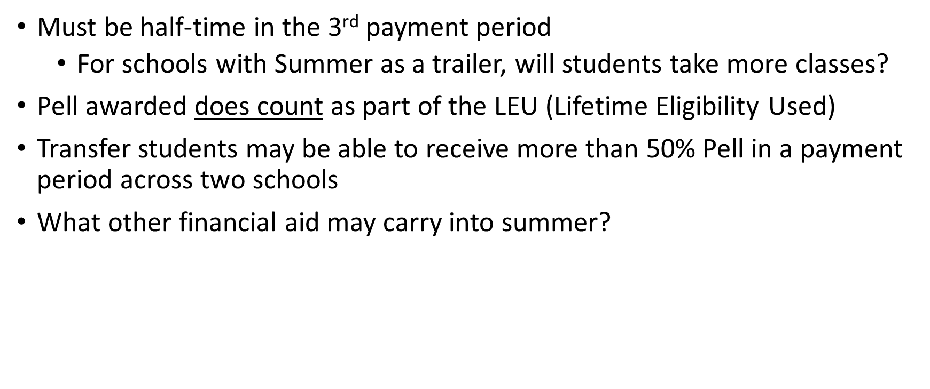



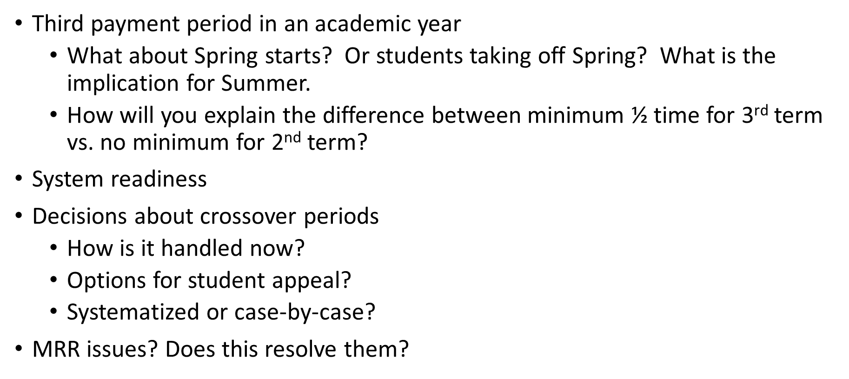

Example (revised for 2020-2021)

* Student enrolls 12/12/12……..…...
* Student enrolls 12/12/3…………….
* Student enrolls 9/9/9…………………
* Student enrolls 9/9/6…………………
* Student enrolls 9/9/3…………………
* Student enrolls 12/9/6……………….
* Student enrolls 12/9/3……………….
* Student enrolls 0/6/12……………….
* Student enrolls 0/6/3…………………

$3,173 / $3,172 / $3,173\*  
$3,173 / $3,172 / $0  
$2,380 / $2,380 / $ 2,380\*  
$2,380 / $2,380 / $1,587  
$2,380 / $2,380 / $793  
$3,173 / $2,380 / $1,587\*  
$3,173 / $2,380 / $793  
$0 / $1,587 / $3,173  
$0 / $1,587 / $793

Normal Pell Maximum award is $6,345. Divided into $3,173 for Fall and $3,172 for Spring

Values of award are $2,380 (3/4 time), $1,587 (1/2 time), $793 (less than ½ time)

